How to generate Patient History Report?

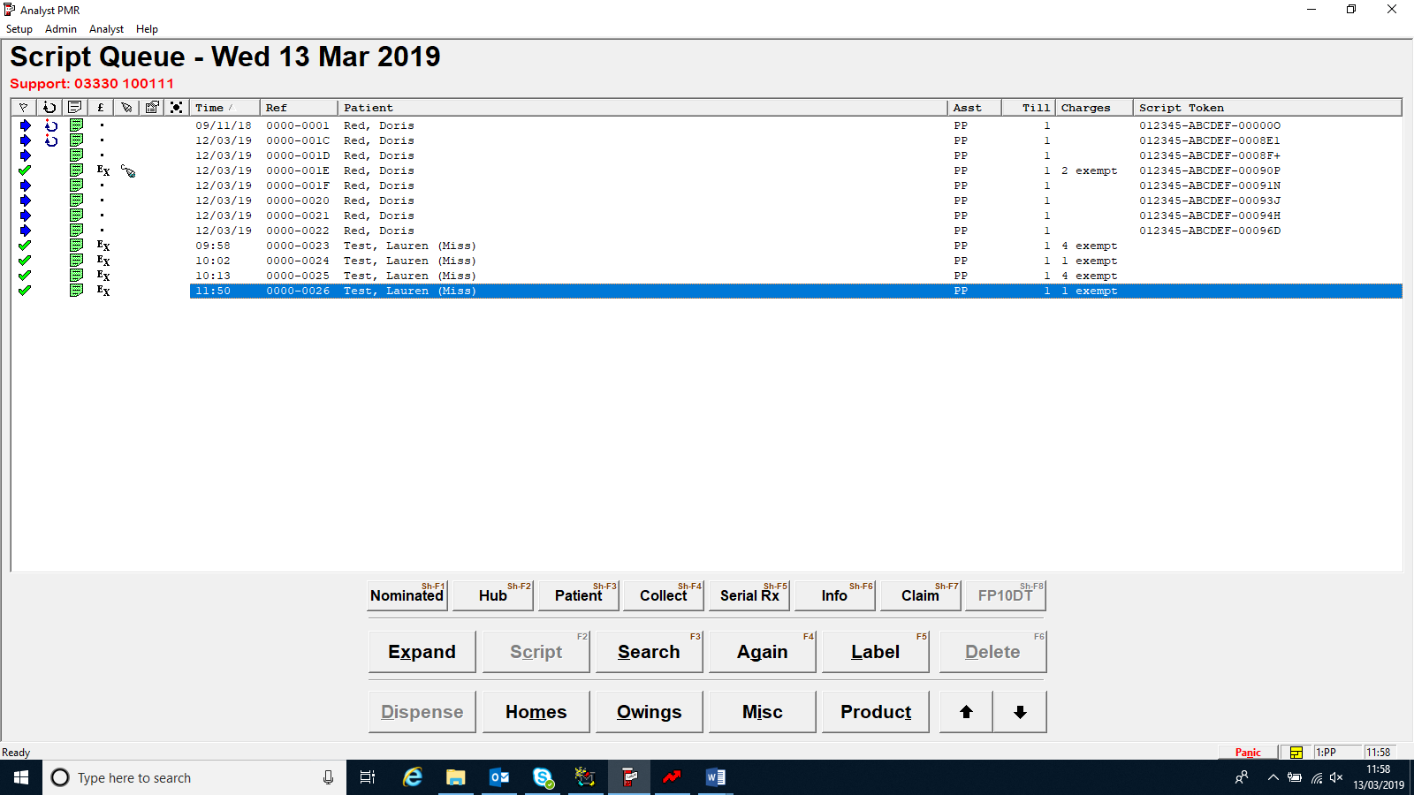
Off the script queue screen go to search.

Type in the patient’s name and press ok.

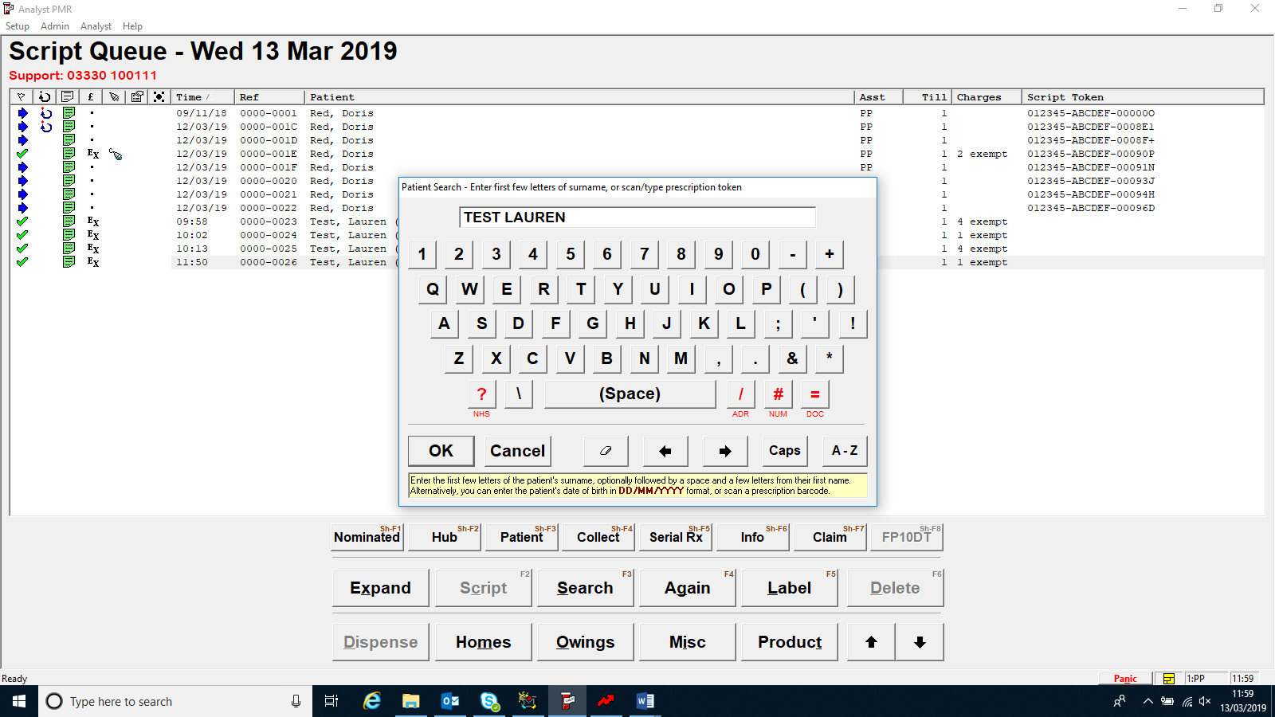

Press ok.

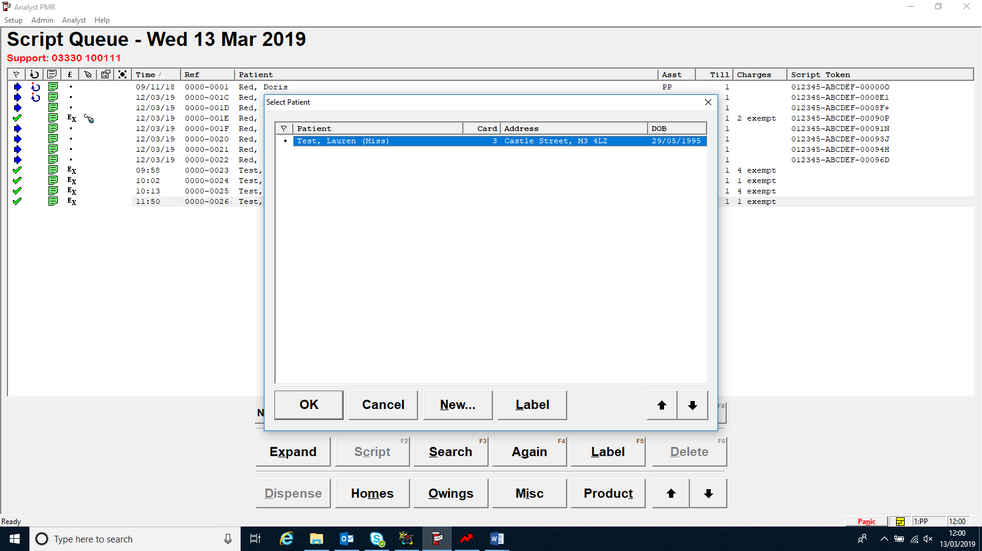

Select patient details box.
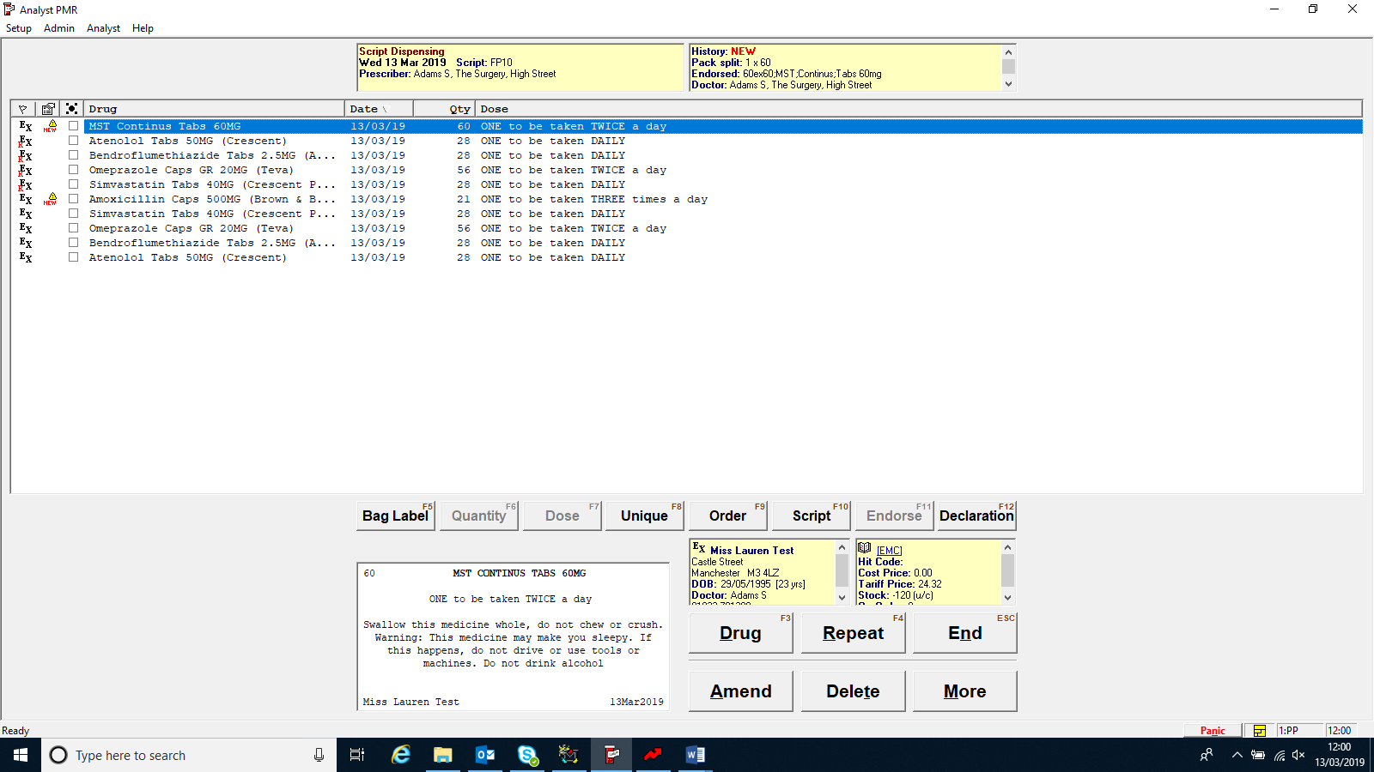

Patient details box appears, go across to history.
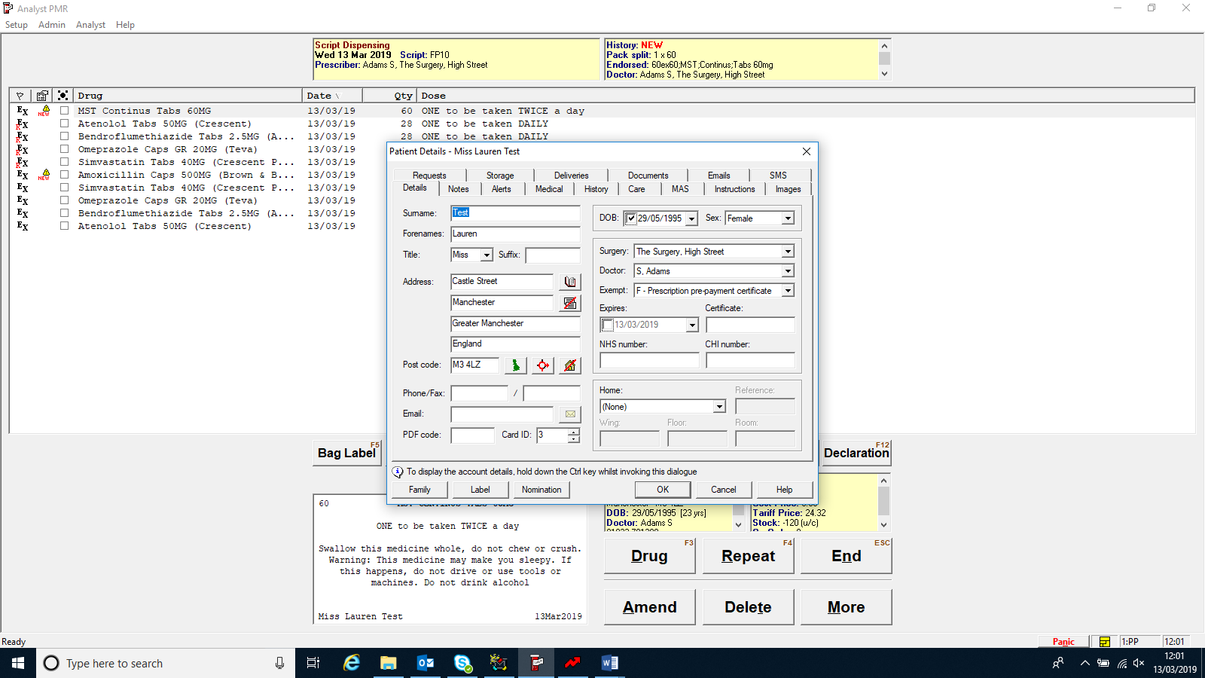

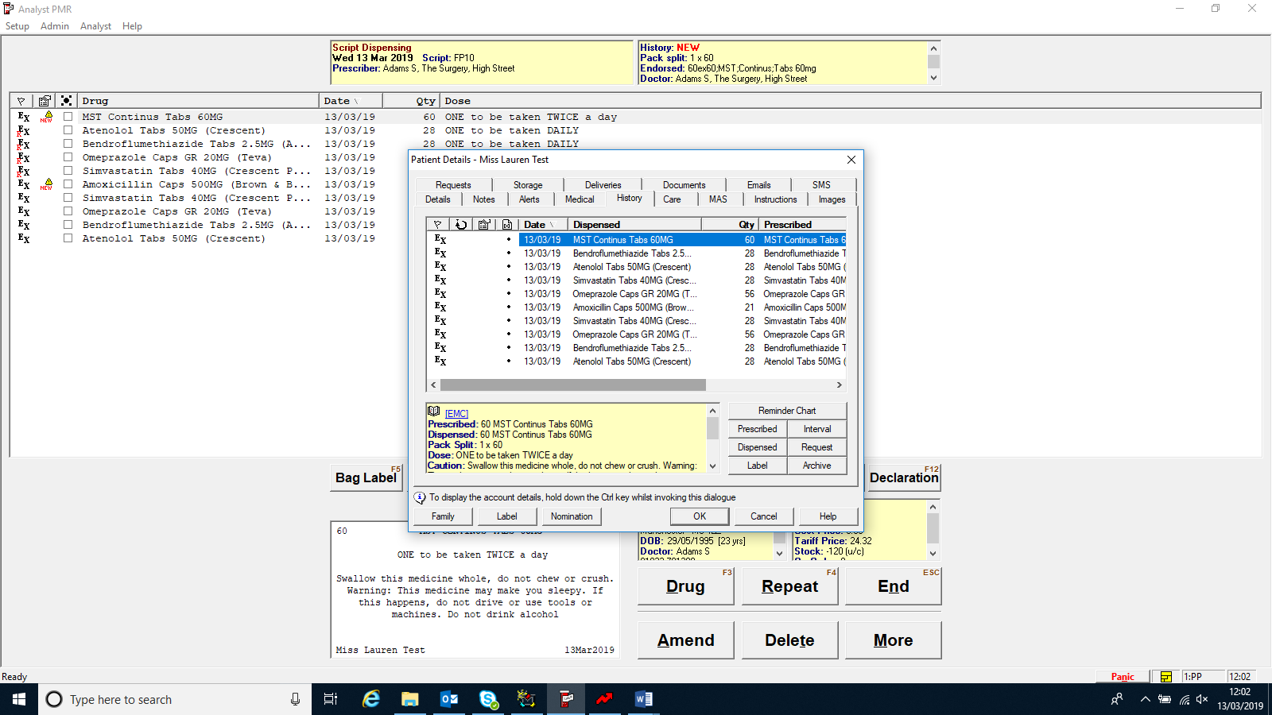
This information then appears and you can scroll across.

select ‘Control’ and ‘P’ on your keyboard it will come up with the option to print

